**National University of Computer & Emerging Sciences, Karachi**Fast **Spring 2022 CS-Department  
Assignment 2**

**Deadline 20 March 2022**

|  |  |
| --- | --- |
| **Course Code: CS3005** | **Course Name: Theory of Automata** |
| **Course Instructors:** | **Musawar Ali, Bakhtawar Abbasi** |
| **Sections:** | **A,B,C,D,E,F** |

**Question 1: (GTG and State Elimination) (10) Points**

**Find the regular expression of the DFA given in figure 1, using state elimination method.**

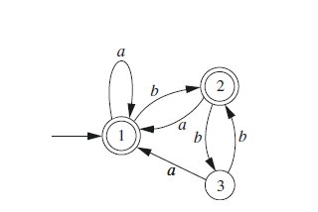

**Figure 1**

**Note : Show steps of your method properly to get full credit.**

**Question 2: (GTG and State Elimination) (10) Points**

**Find the regular expression of the DFA given in figure 2, using state elimination method.**

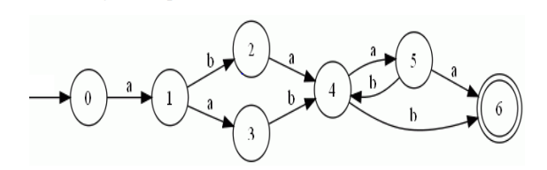

**Figure 2**

**Note : Show steps of your method properly to get full credit.**

**Question 3: (Conversion Epsilon NFA to DFA) 10 Points**

**Construct the DFA from the Epsilon NFA given in figure 3.**

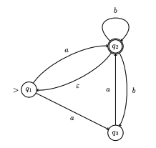

**Figure 3**

**Note: Show steps of your method properly to get full credit.**

**Question 4: (Conversion epsilon-NFA to DFA) 10 Points**

**Construct the DFA from the Epsilon NFA given in figure 4.**

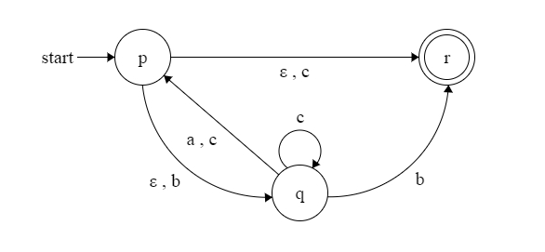

**Figure 4**

**Note: Show steps of your method properly to get full credit.**

**Question 5: (Conversion NFA to DFA) 10 Points**

**Construct the DFA from the Epsilon NFA given in figure 5.**

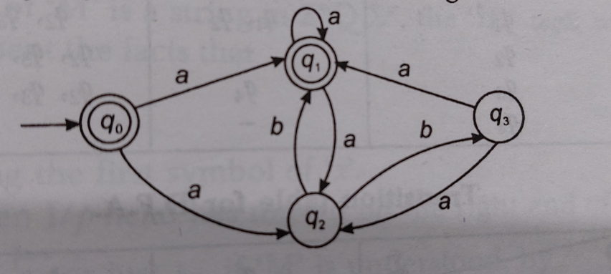

**Figure 5**

**Note: Show steps of your method properly to get full credit.**

**Question 6: (10+10+10+10) Points**

**1. Find the Concatenation of FA1 and FA2 given in Figure 6 and Figure 7.**

**2. Find the Union of FA1 and FA2 given in Figure 6 and Figure 7.**

**3. Find the Intersection of FA1 and FA2 given in Figure 6 and Figure 7.**

**4. Find the Closure of FA1 given in Figure 6.**

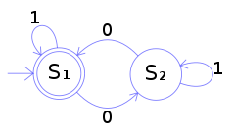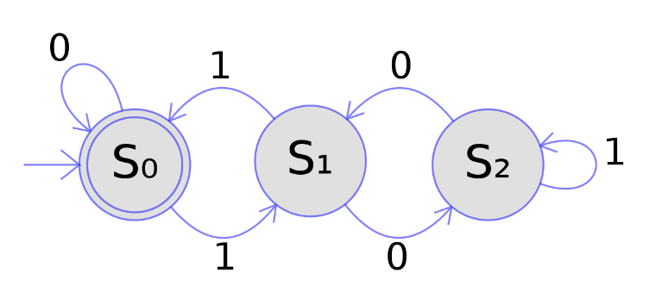

**Figure 6 Figure 7**

**Note: Show steps of your method properly to get full credit.**

***BEST OF LUCK!***